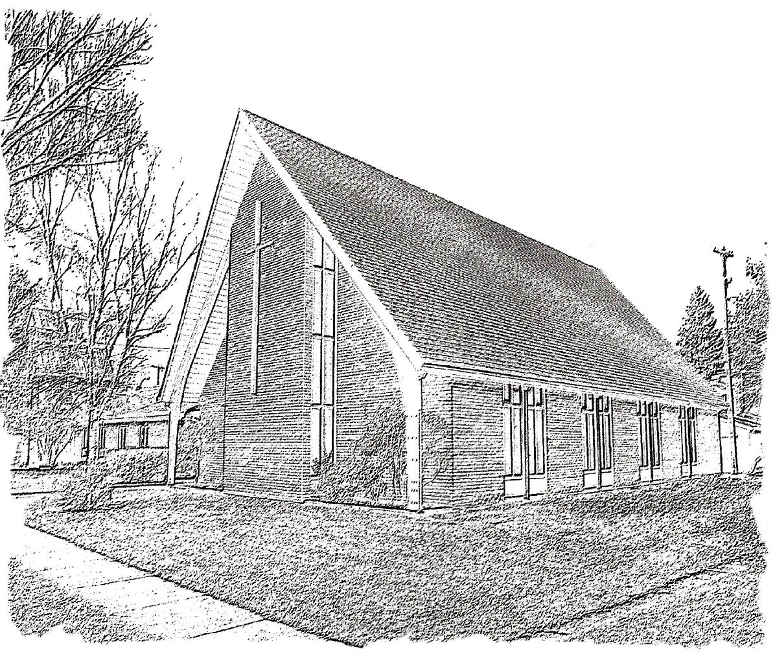
Trinity Sunday
June 4, 2023 - 10:30 a.m.
The Anglican Parish of St. Peter, Winnipeg
Purpose: To be a Christian community seeking to love God, grow in faith, and serve the world.
WE EXTEND A WARM WELCOME TO ALL VISITORS AND NEWCOMERS

In order to facilitate a safe worship experience for everyone,
please keep to the following guidelines:

MASKS are optional for parishioners during the worship service. Administrants will continue to wear a mask when administering the bread and wine during Holy Communion.

SOCIAL DISTANCING is encouraged. You are welcome to sit wherever you like, but please respect the comfort of other parishioners. Please ask for permission before sitting with or approaching other people as some people may prefer to keep a safe distance from others.

NEED TO SIT DURING WORSHIP? There are often long periods of time when we stand during worship, please feel free to sit down at any time.

EXCHANGE THE PEACE if you are comfortable with doing so, feel free to exchange the peace with a handshake or fist bump. If you’re not comfortable with physical contact at this time, please indicate this with a wave, a bow, or some other gesture. In all cases, please be mindful of other people’s comfort level.

COMMUNION All are welcome to receive communion. Gluten free wafers are available upon request. Please follow the direction of the sides people when coming forward to receive Communion. Please use hand sanitizer at the front of the pews.

PRAYER BOWL If there is someone for whom you wish silent prayers, you are invited to write their name on one of the slips of paper provided and place it in the prayer bowl at the back of the church (on the sound equipment cabinet.)

WE ARE A NUT AND SCENT AWARE ENVIRONMENT Many people, especially children are struggling with allergies to nut products with potentially deadly consequences. Many people also have sensitivities to some scents. We have asked parishioners to be aware of this, to refrain from bringing nut products to Church, and from wearing highly scented products.

In the spirit of inclusivity, and as part of the Body of Christ, St. Peter’s welcomes parishioners to actively participate in Sunday services (e.g., leading prayer, sharing a reading, or canting the Psalm) via Zoom when their circumstances may limit them from attending in person. This means that when you attend in person, you may sometimes hear someone's voice through the audio system, rather than seeing them physically at the church. When there are virtual participants contributing to a service, the Presider or Officiant will acknowledge that they are joining us online, in advance of them speaking or canting.

Following today’s worship service you are cordially invited to meet in the parish hall for a time of conversation and refreshments.
Please take your bulletin home to read, record important dates, and recycle
The Holy Eucharist
The Gathering Of The Community

Prelude

Acknowledgement of the Land
Intercessor: We take this time to acknowledge that St. Peter's Anglican Church worships on Treaty 1 land, first inhabited by the Anishinaabe, Dakota and Cree people and homeland of the Red River Metis Nation. We recognize the hospitality extended to us. We are truly sorry for the great harm caused by colonialism in the past and to this day. With God's help, we commit to the process of reconciliation to bring healing to relationships and to the land.

Welcome / Announcements
Intercessor: Announcements that reflect some of the numerous ministries that occur in and through St. Peter’s.

Presider: Welcome. Invitation to share.

(Sounding Bowl)

Opening Hymn: CP#1 Holy, Holy, Holy, Lord God Almighty

The Greeting

Presider: The grace of our Lord Jesus Christ, and the love of God, and the communion of the Holy Spirit, be with you all.
All: And also with you.

Officiant: Almighty God
All: to you all hearts are open, all desires known, and from you no secrets are hidden. Cleanse the thoughts of our hearts by the inspiration of your Holy Spirit, that we may perfectly love you, and worthily magnify your holy name; through Christ our Lord. Amen

Gloria Please Refer to Insert

Collect of the Day
Officiant: Let us pray
All: Enfolding God, Trinity of love, you are our source, our goal, our life: may we be born again in you, no more to live alone and unconnected, but, sharing the Spirit’s breath, be carried to your heart; through Jesus Christ, who lifts us up. Amen. Prayers for an Inclusive Church (2009) alt.
The Proclamation of the Word

Officiant: Let us now feast at the table of God’s word.

Lesson: Genesis 1:1-2:4a
Reader: Hear what the Spirit is saying to the church.
All: Thanks be to God.

Psalm 8 Refer to Attachment.

Lesson: 2 Corinthians 13:11-13
Reader: Hear what the Spirit is saying to the church.
All: Thanks be to God.

Gradual Hymn: CP#598 Go to the World v. 1-2 (Sung to the Tune SINE NOMINE at #387)

Gospel: Matthew 28:16-20
Reader: The Lord be with you.
All: And also with you
Reader: The Holy Gospel of our Lord Jesus Christ according to Matthew
All: Glory to you, Lord Jesus Christ.
Reader: The Gospel of Christ
All: Praise to you, Lord Jesus Christ.

Gradual Hymn: CP#598 Go to the World v. 4 (Sung to the Tune SINE NOMINE at #387)

Sermon
(pause for silent reflection)

Statement of Faith

Officiant: Let us together say the Statement of Faith
All: We are not alone, we live in God’s world. We believe in God: who has created and is creating, who has come in Jesus, the Word made flesh, to reconcile and make new, who works in us and others by the Spirit. We trust in God. We are called to be the Church: to celebrate God’s presence, to live with respect in Creation, to love and serve others, to seek justice and resist evil, to proclaim Jesus, crucified and risen, our judge and our hope. In life, in death, in life beyond death, God is with us. We are not alone. Thanks be to God.

Intercessor: Prayers of the People

Confession and Absolution
Officiant: Dear friends in Christ, God is steadfast in love and infinite in mercy; God welcomes sinners and invites us to this table. Let us confess our sins, confident in God’s forgiveness.

(pause for silent reflection)

Officiant: Most merciful God,
All: we confess that we have sinned against you in thought, word, and deed, by what we have done, and by what we have left undone. We have not loved you with our whole heart; we have not loved our neighbours as ourselves. We are truly sorry and we humbly repent. For the sake of your Son Jesus Christ, have mercy on us and forgive us, that we may delight in your will, and walk in your ways, to the glory of your name. Amen.

Presider: Almighty God have mercy upon you, pardon and deliver you from all your sins, confirm and strengthen you in all goodness, and keep you in eternal life; through Jesus Christ our Lord.
All: Amen.

The Peace
Presider: The peace of Christ be always with you.
All: And also with you.

The Celebration of the Eucharist

Procession of the Gifts
Officiant: From the abundance of God's creation we bring forward bread and wine
and offer them to God.
Officiant: The table for our celebration of the Eucharist will now be prepared as we sing the offertory hymn

Offertory Hymn: CP#572 Let There be Light

Officiant: Let us with joy present these offerings which represent our labour and our lives.
Prayer over the Gifts
Presider: Let us pray.
All: Living God, receive all we offer you this day. Grant that hearing your word and responding to your Spirit, we may share in your divine life. We ask this in the name of Jesus Christ the Lord.

Eucharistic Prayer #3 B.A.S. 198
Presider: The Lord be with you
All: And also with you.
Presider: Lift up your hearts.
All: We lift them to the Lord.
Presider: Let us give thanks to the Lord our God.
All: It is right to give our thanks and praise.

Presider: Blessed are you, gracious God, creator of heaven and earth;………………… Therefore with all the company of heaven we raise our voices to proclaim the glory of your name.
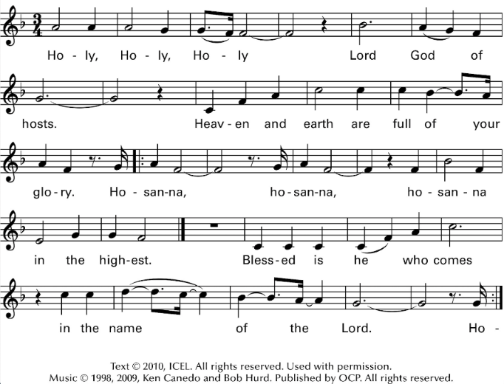
All:

Presider: We give thanks to you, Lord our God, for the goodness and love you have made known to us in creation;…………………Whenever you drink it, do this for the remembrance of me.”

Presider: Therefore, Father, according to his command:
All: we remember his death,
we proclaim his resurrection,
we await his coming in glory

Presider: and we offer our sacrifice of praise and thanksgiving to you, Lord of all; presenting to you, from your creation, this bread and this wine. We pray you, gracious God, to send your Holy Spirit upon these gifts, that they may be the sacrament of the body of Christ and his blood of the new covenant. (SOUNDING BOWL) Unite us to your Son in his sacrifice,………………….in the unity of the Holy Spirit, all honour and glory are yours, almighty Father, now and for ever.
All: Amen.

Presider: As our Saviour taught us, let us pray,
All Sing: Our Father in heaven, hallowed be your name, your kingdom come, your will be done, on earth as in heaven. Give us today our daily bread. Forgive us our sins as we forgive those who sin against us. Save us from the time of trial, and deliver us from evil. For the kingdom, the power, and the glory are yours, now and for ever. Amen. David Fraser

The Breaking of the Bread
Presider: We break this bread to share in the body of Christ.
All: We, being many, are one body, for we all share in the one bread.

Invitation to Communion
Presider: The Gifts of God for the people of God.
All: Thanks be to God.

Communion Hymn: CP#59 Jesus Calls Us Here to Meet Him

Communion Hymn: Bread of Life
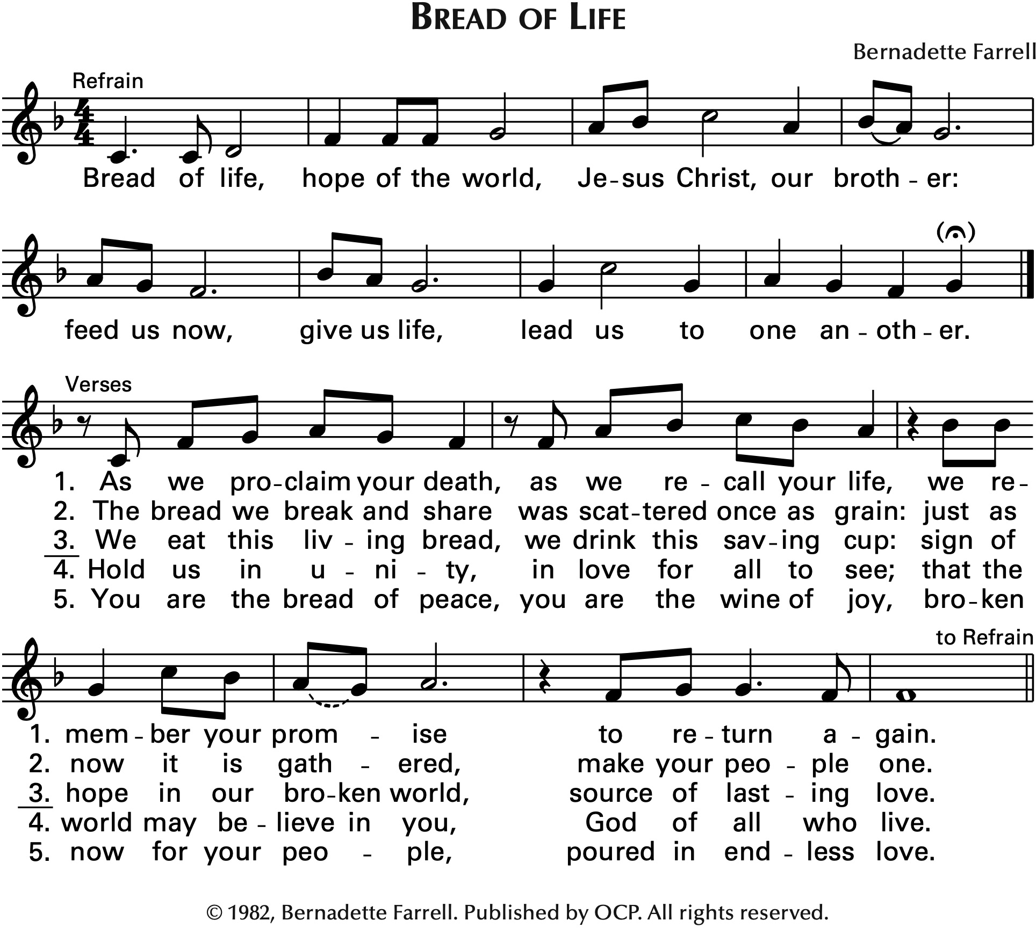
Communion Hymn: CP#402 Come and Fill our Hearts

Prayer after Communion
Presider: Let us pray
All: Almighty and eternal God, may we who have received this eucharist worship you in all we do, and proclaim the glory of your majesty. We ask this in the name of Jesus Christ the Lord.

Presider: Glory to God
All: whose power, working in us, can do infinitely more than we can ask or imagine. Glory to God from generation to generation, in the Church and in Christ Jesus, forever and ever. Amen.
The Dismissal

Closing Hymn: CP#256 Yours the Hand that Made Creation

Sending Forth of the Eucharistic Minister
Presider: In the name of this congregation, I send you forth bearing these holy gifts, that those to whom you go may share with us in the communion of Christ’s body and blood. One body are we,
All: for though many, we share one bread and one cup.

Presider: May the peace of God, which passes all understanding, keep your hearts and minds in the knowledge and love of God, and of his Son Jesus Christ our Lord; and the blessing of God Almighty, the Father, the Son, and the Holy Spirit, be among you, and remain with you always.
All: Amen

Presider: Go in peace to love and serve the Lord. Alleluia!
All: Thanks be to God! Alleluia!

Postlude

PRAYERS

Please include in your prayers Beth Hiscox, Gladys Oelkers, Ruth Kensinger, Ginny and Bob Kellington, Joan Cook, George Green, Roy and Annie Bowkett, Bev Smith, Junior Jackson, Terri Oelkers, Bryan (Rusty) Slater, Liza, Gina Linklater, Katie Muehling, Ellen Gould, Mark, Reynald, Taytum, Alex Bidochka, Doug.

In our parish cycle of prayer: Sue Slater, Beverley Smith, Maureen Tate, Kerry Taylor.

In the Anglican Communion worldwide, we pray for The Episcopal / Anglican Province of Alexandria. In the ACC, our Primate Linda, National Indigenous Archbishop Christopher and the Anglican Council of Indigenous People, our Metropolitan Greg, the theological colleges and training programs within the Ecclesiastical Province of Ontario. In the ELCIC, National Bishop Susan, Luther College at the University of Regina and Luther College – High School. Council of the North, Diocese of Yukon. In our Diocese, our Bishop Geoffrey, Bishop of our Companion Diocese, Michael, and for MNO Synodical Bishop Jason. Our Congregations and Communities, especially the clergy and people of Holy Trinity: Winnipeg, Headingly, and Minnitaki.

Please pray for the peaceful repose of Vera Sim who died May 22nd. Please keep Vera’s family in your thoughts and prayers as they mourn the loss of their loved one.

Obituary for Vera Florence Sim (nee BAILEY)
Vera was born in London, England on September 10th, 1923, and passed away after a brief illness on May 22, 2023. Vera and Robert Bruce Sim married on April 15, 1944, and Vera immigrated to Winnipeg in March 1946. Bruce and Vera settled in River Heights in 1949. Vera was a faithful member of Christ Church and St. Peter’s Anglican churches, serving in many capacities. She was awarded the Order of Rupert’s Land for her service to the Anglican Church. She was a person of many interests including writing, quilting, gardening, and painting, and she especially loved children. Vera was predeceased by Bruce, an infant son (Anthony), and granddaughter (Emmanuelle). Vera is survived by her children, Robert (Cathie), Kathryn (Claude), and Sheila (Mike); grandchildren, Carolyn, Jill, Will, Sara, and Alex; step-grandchildren, Greg, Darcy, Matthew, David, Jocelyn and Chris, and many great-grandchildren.
The family wishes to thank Gwen Sutton for her friendship to our mother. Vera requested that a service not be held.

PARISH and COMMUNITY LIFE

NEEDED: Church Gardening Volunteers
Now that spring has arrived, we are looking for people to help maintain our gardens. This would involve: watering and weeding the flower tubs and beds weekly (depending on the amount of sun and rain) and alternating the Elm St and Grant Ave beds (1/week)
The commitment usually means 2 or 3 weeks per season, depending on the number of volunteers. If you are interested in knowing more about this ministry, please speak with Betty Currie. A sign-up sheet is in the Narthex. An orientation will be provided. It is a pleasant activity to share with a friend!

Winnipeg Pride Parade TODAY!
Please join us immediately after the service!! You are invited to join MNO Synod and the Diocese of Ruperts Land in the Winnipeg Pride Parade. The MNO Synod Facebook event page will be updated as more information becomes available. https://bit.ly/3HkOGdn

Growing in Wisdom: Seeking Deeper Generativity
This ecumenical program is grounded in the mystical Christian Tradition, open to learning from other interfaith and spiritual traditions, and designed for those seeking to engage in their maturing years with wisdom and grace. This program is rooted in the Forest Dwelling Program, Oblate School of Theology, and the ground-breaking work of Fr. Ron Rolheiser OMI. Applications are now being accepted for the September 2023 – June 2025 program. A free information event is being offered on Zoom on Thursday, June 8th 1:00 – 4:00 pm CDT or Wednesday June 21st 1:00 – 4:00 pm CDT. To register, visit the Growing in Wisdom website: www.growinginwisdom.ca.
You are welcome to direct your questions to Nancy Phillips, Coordinator, email: growinginwisdom@outlook.com

Consider the Lilies 2023 Conference
Taking place June 9-11 at St. Margaret's Anglican Church (160 Ethelbert St.), Consider the Lilies is the first annual conference of its kind in Winnipeg for Christians and church leaders to learn about, discuss, workshop, and commit to creation care. If you are interested in how Christianity and caring for the earth intersect, this conference is for you! The conference aims to provide robust theological education, equipping church-goers and church leaders to care for creation in their own unique contexts. Featuring a Friday evening keynote lecture, multiple lectures and activities all-day Saturday (including activities for kids), and a closing worship service Sunday, participants are welcome to attend the entire conference or just parts of it. See the full schedule and register at www.arocha.ca/consider. Alternatively, you can contact St. Margaret's Anglican Church at office@saintmargarets.ca or 204-783-5753.

Grow Hope
Grow Hope 2023 is off to a great start. Thanks to those who have donated already, we’ve raised about $1,100 of our $4,000 goal. Along with other parishes in our Diocese we are partnering with the Wiebe farm family near Springstein. Our donations help to offset the input costs of 40 acres of soybeans. The Wiebe’s will tend the field all summer and at harvest time will sell this crop and donate all the proceeds through the Canadian Food Grains Bank. Proceeds will go directly to support a PWRDF project in Nyaragusu, Tanzania. Mary Obiero, who visited us last month, will be leading this project. Details on the project can be found on St. Peter’s website.
Watch the grain elevator poster in the Narthex to track progress toward our goal.

Annual Urban Retreats Garden Tour
Coming up June 24. This is a great way to spend part of a Saturday, feeding your soul visiting 13 beautiful gardens in the south St. Vital neighbourhood. This event is a major fundraiser supporting 1JustCity - West End Drop-In. You can also stop by The United Church in Meadowood for a Manitoba Tea, Craft and Bake Sale. Tour tickets are $20 and available from Margaret Clarke. Your ticket is your guide and includes a map. Tea tickets are $5 at the door.

Donations
If you would like to contribute to the ongoing ministries of St. Peter’s Anglican Church, there are several convenient ways you can do this:
- Ongoing PAR (Pre-Authorized Remittance) donations can be set up with Laurie Thompson, our Envelope Secretary - contact the church office for her contact info.
- Mail in or drop off a cheque to the church building.
- Donate online through Canada Helps. On the donation page, you are able to allocate your donation to the Primates World Relief and Development Fund, Capital Projects, Mission & Outreach Projects, Grow Hope Project, etc. You will receive your charitable donation receipt immediately upon making the donation. The funds less a nominal administration fee go directly to St. Peter's.

The Diocese of Rupert’s Land
The Anglican Parish of St. Peter

755 Elm Street, Winnipeg, Manitoba R3M 3N8
E-mail: administrator@stpetersanglican.ca
Phone: 204-488-8093 FAX: 204-489-0425
Website: www.stpetersanglican.ca

Bishop of Rupert’s Land: The Right Rev. Geoffrey Woodcroft
Incumbent The Rev. R. Susan Smandych
Honorary Assistant: The Rev. Canon Mary Holmen
Director of Music Ministry: David Fraser
Rector’s Warden: Colin Dorrian
People’s Warden: Joan Crabtree
Deputy People’s Warden: Caroline LeNabat
Treasurers: Sabrina Day, Jane Ferch
Envelope Secretary: Laurie Thompson
Administrative Assistant: Tara Acklom

ASSISTING IN TODAY’S SERVICE

Presider Rev. R. Susan Smandych Cantor Choir
Preacher Rev. R. Susan Smandych Eucharistic Minister Mary Holmen
Officiant Betty Currie Altar Guild Pat Ahmad
Intercessor Lynda Wolf Leone Hillier
Reader Jane Ferch Host Linda Ellis
Administrants Rev. R. Susan Smandych Zoom Host Serene Desmond
Betty Currie Technical Support Dan Torbiak
Gospel Betty Currie Sides People Linda Ellis
Organist David Fraser Jim Ellis
Sounding Bowl: TBD

Permission to use the prelude and postlude in this service obtained from ONE LICENSE,
License #A-719294. All rights reserved.
All reprinted music in this bulletin is reprinted with permission under ONE LICENSE, License #A-719294.

Readings for Sunday, June 11th:
Genesis 12:1-9; Psalm 33:1-12; Romans 4:13-25, Matthew 9:9-13, 18-26

