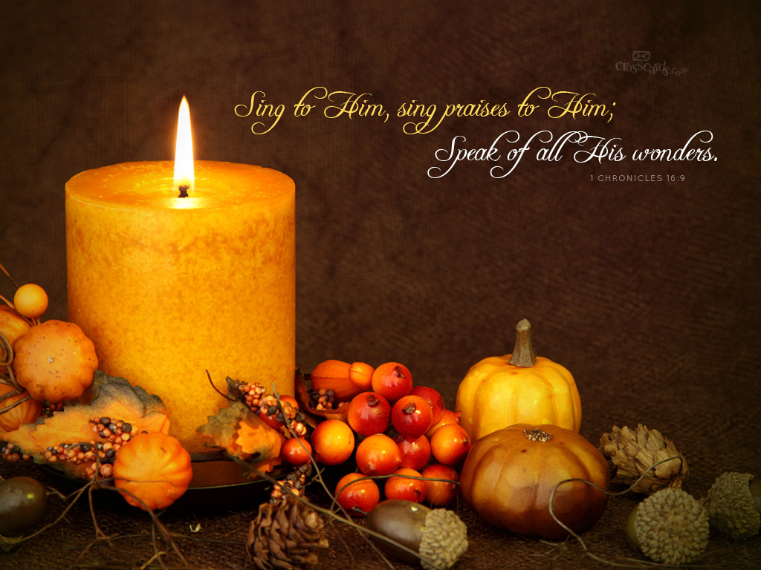

Twentieth Sunday after Pentecost

October 15, 2023 – 10:30 a.m.
The Anglican Parish of St. Peter, Winnipeg

Purpose: To be a Christian community seeking to love God, grow in faith, and serve the world.

WE EXTEND A WARM WELCOME TO ALL VISITORS AND NEWCOMERS
Please adhere to the following guidelines for a safe and comfortable worship experience.

MASKS are optional for parishioners during the worship service.
SOCIAL DISTANCING is encouraged. You are welcome to sit wherever you like, but please respect the comfort of other parishioners. Please ask for permission before sitting with or approaching other people as some people may prefer to keep a safe distance from others.
NEED TO SIT DURING WORSHIP? There are often long periods of time when we stand during worship, please feel free to sit down at any time.
EXCHANGE THE PEACE if you are comfortable with doing so, feel free to exchange the peace with a handshake or fist bump. If you’re not comfortable with physical contact at this time, please indicate this with a wave, a bow, or some other gesture. In all cases, please be mindful of other people’s comfort level.
COMMUNION: All are welcome to receive Communion. Gluten free wafers are available on request. Please follow the direction of the sides people and form a single line in the center aisle to receive the bread, maintaining some physical distance. It is helpful to the Presider if you open your hands flat rather than cupping them, to avoid direct contact. Move to either side to receive the wine. If you do not wish to receive from the common cup, you may touch the base of the chalice (or touch the bread/wafer to the base) and reply “Amen” to the words of administration. Intinction (dipping the bread/wafer into the wine) is not allowed. If you do not wish to receive either the bread/wafer or wine, you may cross your arms over your chest for a blessing. Please return down the side aisle to your seat. Healing prayer is available at the back of the nave for those who wish it.
PRAYER BOWL If there is someone for whom you wish silent prayers, you are invited to write their name on one of the slips of paper provided and place it in the prayer bowl at the back of the church (on the sound equipment cabinet.)
WE ARE A NUT AND SCENT AWARE ENVIRONMENT Many people, especially children are struggling with allergies to nut products with potentially deadly consequences. Many people also have sensitivities to some scents. We have asked parishioners to be aware of this, to refrain from bringing nut products to Church, and from wearing highly scented products.

In the spirit of inclusivity, and as part of the Body of Christ, St. Peter’s welcomes parishioners to actively participate in Sunday services (e.g., leading prayer, sharing a reading, or canting the Psalm) via Zoom when their circumstances may limit them from attending in person. This means that when you attend in person, you may sometimes hear someone's voice through the audio system, rather than seeing them physically at the church. When there are virtual participants contributing to a service, the Presider or Officiant will acknowledge that they are joining us online, in advance of them speaking or canting.

Please take your bulletin home to read, record important dates, and recycle

The Holy Eucharist
The Gathering Of The Community

Prelude

Acknowledgement of the Land

Intercessor: During fall, as the land and living creatures prepare for their winter rest, the people of St Peter’s prepare to worship by acknowledging that we are located on Treaty 1 land, the traditional lands of the Anishinaabe, Cree, and Dakota peoples and the homeland of the Red River Metis Nation. We honour the teachings of their elders and their care of the land. We acknowledge the role of the church in excluding and dispossessing First Nations people from their land. As the land begins to rest, we settler people commit to building better relationships and to honouring treaties with Indigenous peoples.

Welcome / Announcements

Intercessor: Announcements that reflect some of the numerous ministries that occur in and through St. Peter’s.

Presider: Welcome. Invitation to share.
(Sounding Bowl)

Opening Hymn: CP#589 Come, O God of all the Earth [Please Stand]

The Greeting
Presider: The grace of our Lord Jesus Christ, and the love of God, and the communion of the Holy Spirit, be with you all.
All: And also with you.

Officiant: Almighty God
All: to you all hearts are open, all desires known, and from you no secrets are hidden. Cleanse the thoughts of our hearts by the inspiration of your Holy Spirit, that we may perfectly love you, and worthily magnify your holy name; through Christ our Lord. Amen.
The Gloria CP#457 All: Refrain: Alleluia, Alleluia, Alleluia

Glory to God who does wondrous things;
let all the people God’s praises now sing;
all of creation in splendour shall ring:
alleluia! Refrain

See how salvation for all has been won;
up from the grave our new life has begun;
life now perfected in Jesus, the Son:
alleluia! Refrain

Now in our presence the Lord will appear,
shine in the faces of all of us here;
fill us with joy and cast out all our fear:
alleluia! Refrain

Collect of the Day
Officiant: Let us pray
All: Lord of the feast, you have prepared a table before all peoples and poured out your life with abundance. Call us again to our banquet. Strengthen us by what is honourable, just, and pure, and transform us into a people of righteousness and peace, through Jesus Christ, our Saviour and Lord. Amen. Evangelical Lutheran Worship (2006)

The Proclamation of the Word

Officiant: Let us now feast at the table of God’s word. [Please be Seated]

First Lesson Exodus 32:1-14
Reader: Hear what the Spirit is saying to the church.
All: Thanks be to God.

Psalm Psalm 106:1-6, 19-23 (Refer to Insert)

Second Lesson Philippians 4:1-9
Reader: Hear what the Spirit is saying to the church.
All: Thanks be to God.

Gradual Hymn: CP#561 Lord, Your Word Shall Guide Us, v.1, 3 [Please Stand]

Gospel Matthew 22:1-14
Reader: The Lord be with you.
All: And also with you.
Reader: The Holy Gospel of our Lord Jesus Christ according to Matthew
All: Glory to you, Lord Jesus Christ.
Reader: The Gospel of Christ
All: Praise to you, Lord Jesus Christ.

Gradual Hymn: CP#561 Lord, Your Word Shall Guide Us, v.1, 6 [Please Stand]
Sermon [Please be Seated]
(Pause for Silent Reflection)

The Apostles’ Creed
Officiant: Let us confess the faith of our baptism, as we say
All: I believe in God, the Father almighty, creator of heaven and earth. I believe in Jesus Christ, his only Son, our Lord. He was conceived by the power of the Holy Spirit and born of the Virgin Mary. He suffered under Pontius Pilate, was crucified, died and was buried. He descended to the dead. On the third day he rose again. He ascended into heaven, and is seated at the right hand of the Father. He will come again to judge the living and the dead. I believe in the Holy Spirit, the holy catholic Church, the communion of saints, the forgiveness of sins, the resurrection of the body, and the life everlasting. Amen.

Prayers of the People

Confession and Absolution
Officiant: Dear friends in Christ, God is steadfast in love and infinite in mercy; God welcomes sinners and invites us to this table. Let us confess our sins, confident in God’s forgiveness.

(Pause for Silent Reflection)

Officiant: Most merciful God,
All: we confess that we have sinned against you in thought, word, and deed, by what we have done, and by what we have left undone. We have not loved you with our whole heart; we have not loved our neighbours as ourselves. We are truly sorry and we humbly repent. For the sake of your Son Jesus Christ, have mercy on us and forgive us, that we may delight in your will, and walk in your ways, to the glory of your name. Amen.

Presider: Almighty God have mercy upon you, pardon and deliver you from all your sins, confirm and strengthen you in all goodness, and keep you in eternal life; through Jesus Christ our Lord.
All: Amen.

The Peace
Presider: The peace of Christ be with you.
All: And also with you.

The Celebration of the Eucharist

Procession of the Gifts
Officiant: From the abundance of God's creation we bring forward bread and wine and offer them to God.
Officiant: The table for our celebration of the Eucharist will now be prepared as we sing the offertory hymn.

Offertory Hymn: CP#563 In God Alone (Repeat as Needed)

Officiant: Let us with joy present these offerings which represent our labour and our lives.

Prayer over the Gifts Evangelical Lutheran Worship (2006) alt.
Presider: Let us pray.
All: Holy God, gracious and merciful, you bring forth food from the earth and nourish your whole creation. Turn our hearts toward those who hunger in any way, so that all may know your care; and prepare us now to feast on the bread of life, Jesus Christ, our Saviour and Lord. Amen.

Eucharistic Prayer #2 B.A.S. 196
Presider: The Lord be with you
All: And also with you.
Presider: Lift up your hearts.
All: We lift them to the Lord.
Presider: Let us give thanks to the Lord our God.
All: It is right to give our thanks and praise.

Presider: We give you thanks and praise, almighty God, through your beloved Son, Jesus Christ, our Saviour and Redeemer. He is your living Word, through whom you have created all things. By the power of the Holy Spirit he took flesh of the Virgin Mary and shared our human nature. He lived and died as one of us, to reconcile us to you, the God and Father of all. In fulfillment of your will he stretched out his hands in suffering, to bring release to those who place their hope in you; and so he won for you a holy people. He chose to bear our griefs and sorrows, and to give up his life on the cross, that he might shatter the chains of evil and death, and banish the darkness of sin and despair. By his resurrection he brings us into the light of your presence. Now with all creation we raise our voices to proclaim the glory of your name.

All: Holy, holy, holy Lord; BELL
God of power and might,
Heaven and earth of your glory are full.
Hosanna, Hosanna, Hosanna in the highest.
Blessed is he who comes in the name of the Lord.
Blessed is he who comes in the name of the Lord.
Holy, holy, holy Lord;
God of power and might,
Heaven and earth of your glory are full.
Hosanna, hosanna, hosanna in the highest.
Hosanna, hosanna, hosanna in the highest.
Presider: Holy and gracious God, accept our praise, through your Son our Saviour Jesus Christ; who on the night he was handed over to suffering and death, took bread and gave you thanks, saying, “Take, and eat: this is my body which is broken for you.” In the same way he took the cup, saying, “This is my blood which is shed for you. When you do this, you do it in memory of me.”

Remembering, therefore, his death and resurrection, we offer you this bread and this cup, giving thanks that you have made us worthy to stand in your presence and serve you.

Presider: We ask you to send your Holy Spirit upon the offering of your holy Church. (SILENCE – SOUNDING BOWL) Gather into one all who share in these sacred mysteries, filling them with the Holy Spirit and confirming their faith in the truth, that together we may praise you and give you glory through your Servant, Jesus Christ. All glory and honour are yours, Father and Son, with the Holy Spirit in the holy Church, now and forever.
All: Amen

Presider: As our Saviour taught us, let us pray:
All: Our Father in heaven, hallowed be your name, your kingdom come, your will be done, on earth as in heaven. Give us today our daily bread. Forgive us our sins as we forgive those who sin against us. Save us from the time of trial, and deliver us from evil. For the kingdom, the power, and the glory are yours, now and for ever. Amen.

The Breaking of the Bread
Presider: Creator of all, you gave us golden fields of wheat, whose many grains we have gathered and made into this one bread.
All: So may your church be gathered from the ends of the earth into your kingdom.

Communion Hymn: CP#69 We Who Live by Sound and Symbol [Please be Seated]

Communion Hymn: Bread for the World
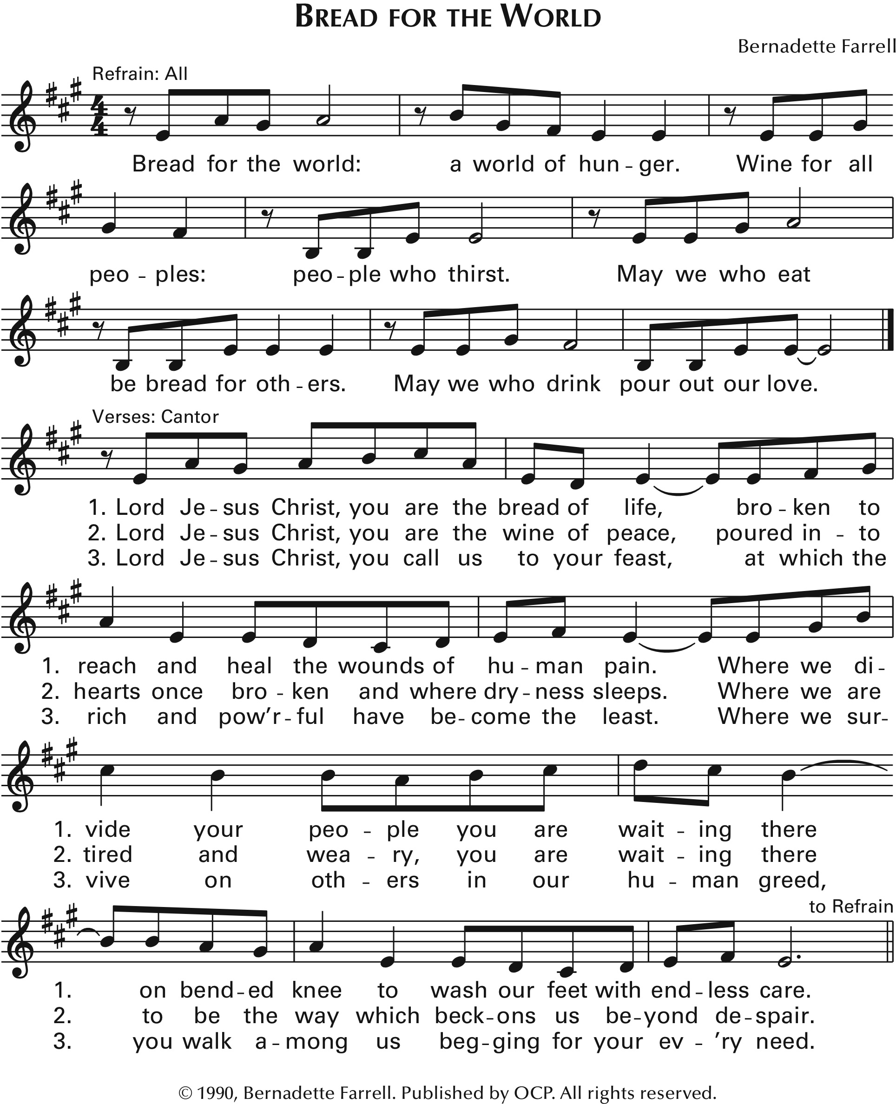
Communion Hymn: CP#63 Eat this Bread (Repeat as Needed)

Prayer after Communion [Please Stand]
Presider: Let us pray,
All: God of abundance, with this bread of life and cup of salvation you have united us with Christ, making us one with all your people. Now send us forth in the power of your Spirit, so that we may proclaim your redeeming love to the world and continue forever in the risen life of Jesus Christ, our Lord. Amen. Evangelical Lutheran Worship (2006) alt.

Doxology
Presider: Glory to God
All: whose power, working in us, can do infinitely more than we can ask or imagine. Glory to God from generation to generation, in the Church and in Christ Jesus, forever and ever. Amen.

THE DISMISSAL

Closing Hymn: CP#600 You Call Us Out to Praise You

Sending Forth of the Eucharistic Minister

Presider: In the name of this congregation, I send you forth bearing these holy gifts, that those to whom you go may share with us in the communion of Christ’s body and blood. One body are we,
All: for though many, we share one bread and one cup.

Blessing

Presider: May the peace of God, which passes all understanding, keep your hearts and minds in the knowledge and love of God, and of His Son Jesus Christ our Lord and the blessing of God Almighty, Father, Son and Holy Spirit, be among you, and remain with you always.
All: Amen

Presider: Go in peace to love and serve the Lord.
All: Thanks be to God!

Postlude

PRAYERS

Please include in your prayers Beth Hiscox, Gladys Oelkers, Ruth Kensinger, Ginny and Bob Kellington, Joan Cook, George Green, Roy and Annie Bowkett, Bev Smith, Junior Jackson, Terri Oelkers, Bryan (Rusty) Slater, Gina Linklater, Katie Muehling, Mark, Reynald, Taytum, Doug, Andrea, Heather, and Mitch.

In our parish cycle of prayer: Rev. Mary Holmen, Evelyn and James Horton, Dan and Carol Iwankow.

In the Anglican Communion worldwide, we Pray for The Anglican Church of Kenya. In the ACC, our Primate Linda, National Indigenous Archbishop Christopher and the Anglican Council of Indigenous People, our Metropolitan Greg, the Most Rev. Lynne McNaughton, Archbishop, and the Clergy and People of the Diocese of Kootenay. In the ELCIC, National Bishop Susan. The Dean, Council, and Congregation of the Vancouver Island Region of the British Columbia Synod. Council of the North, Archdeaconry of Labrador in the Diocese of Eastern Newfoundland and Labrador. In our Diocese, our Bishop Geoffrey, Bishop of our Companion Diocese, Michael, and for MNO Synodical Bishop Jason. Our Congregations and Communities, especially the Clergy and People of St. Luke, Winnipeg; St. Luke, Oakville; St. Luke, Dryden.

PARISH and COMMUNITY LIFE

Ellen Gould Funeral
Saturday, October 21st at 10:30 a.m. with reception to follow. All are invited to celebrate the life of this faithful disciple of Christ.

Sharing from our Abundance:
Throughout the month of October, St. Peter’s is partnering with the children and families of KIDS Inc. to share non-perishable food items for the West End Drop-In of 1JustCity. You can see the baskets filling on the Narthex table. The children have made posters inviting us to share too. Let’s support this partnership by offering our donations, for the benefit of the guests at West End. Thank you from your Outreach Ministry Team.

Shoestring Players
Shoestring Players have been a long time renter here at St. Peter’s Anglican Church. If you are interested in joining a well-established, fun, and dynamic theatre group, then Shoestring Players would like to invite you to their auditions on Sunday, October 15th between 1pm – 4pm in the church hall. Visit their website www.shoestringplayerswinnipeg.com for more information.

October is Sock-tober
KIDS Inc. is inviting us to partner with them for Sock-tober. New socks are being collected for Main Street Project. If you would like to participate, donations of new socks can be added to their decorative box in the Narthex. Thank you from the children of KIDS Inc.
Worship Ministry
In the spirit of inclusivity, and as part of the Body of Christ, St. Peter’s welcomes parishioners to actively participate in Sunday services (e.g., leading prayer, sharing a reading, or canting the Psalm) via Zoom when their circumstances may limit them from attending in person. This means that when you attend in person, you may sometimes hear someone's voice through the audio system, rather than seeing them physically at the church. When there are virtual participants contributing to a service, the Presider or Officiant will acknowledge that they are joining us online, in advance of them speaking or canting. If you are interested in joining our worship ministry, we would love to hear from you. Please contact Rev. R. Susan Smandych, Joan Crabtree, or the office administrator for more information.

An Introduction to the Psalms
What are Psalms? What are Psalms telling us? Why do we usually sing Psalms? To learn the answers to these questions and much more, please plan on attending an interactive workshop titled An Introduction to the Psalms, presented by The Rev. Canon Mary Holmen and Lynda Wolf. The event will take place on Saturday, October 28, 2023 9:00 am to noon at St. Peter’s. Bring your Bible along with you. Coffee, tea and snacks will be provided. No cost to attend. Please register by October 22 on the sign-up sheet in the Narthex, or by emailing administrator@stpetersanglican.ca. All are welcome, so please spread the word to your friends and neighbours! For any additional information see Laurie Thompson. We hope you can join us for a morning of fellowship and education!

Faith Forward Committee
The Faith Forward Committee along with Parish leadership has invited an independent facilitator to host a faithful discussion amongst parishioners on what we want St. Peter’s to look like in 5, 10, or 20 years from now. We all have ideas about what God is calling us to, and this is an important opportunity to both speak and listen to others in our parish. Please mark this date on your calendars: Saturday, Nov. 4th 9:00am to 2:30pm in the parish hall. Coffee and lunch will be provided. We want to hear what you have to say!

The Diocese of Rupert’s Land
The Anglican Parish of St. Peter

755 Elm Street, Winnipeg, Manitoba R3M 3N8
E-mail: administrator@stpetersanglican.ca
Phone: 204-488-8093 FAX: 204-489-0425
Website: www.stpetersanglican.ca

Bishop of Rupert’s Land: The Right Rev. Geoffrey Woodcroft
Incumbent The Rev. R. Susan Smandych
Honorary Assistant: The Rev. Canon Mary Holmen
Director of Music Ministry: David Fraser
Rector’s Warden: Colin Dorrian
People’s Warden: Joan Crabtree
Deputy People’s Warden: Caroline LeNabat
Treasurers: Sabrina Day, Jane Ferch
Envelope Secretary: Laurie Thompson
Administrative Assistant: Tara Acklom

ASSISTING IN TODAY’S SERVICE

Presider Aubrey Hemminger Gospel Betty Currie
Preacher Peter Mitchell Eucharistic Minister Mary DeGrow
Officiant Betty Currie Altar Guild Cori Dorrian
Intercessor Erin-Brie Warwick Mary DeGrow
Reader Noreen Watt Host Marie Cook
Administrants Aubrey Hemminger Zoom Host David Thompson
Betty Currie Technical Support Durell Desmond
Jane Ferch Sides People Francis Cook
Music Leader David Fraser Marie Cook
Refreshments N/A Sounding Bowl Laurie Thompson
N/A Cantor: Erin-Brie Warwick
Prayer Team Joan Crabtree
Maureen Tate

Permission to use the prelude and postlude in this service obtained from ONE LICENSE,
License #A-719294. All rights reserved.
All reprinted music in this bulletin is reprinted with permission under ONE LICENSE, License #A-719294.

Readings for Sunday, October 22nd:
Exodus 33:12-23; Psalm 99; 1 Thessalonians 1:1-10; Matthew 22:15-22

